2.9: a) At 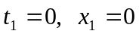, so Eq (2.2) gives
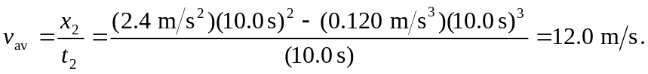

b) From Eq. (2.3), the instantaneous velocity as a function of time is

so i) 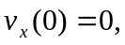
ii)
and iii)
c) The car is at rest when 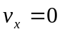. Therefore 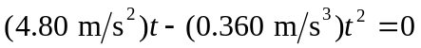. The only time after  when the car is at rest is 